**France - Source URL Analysis**

**URL:** <https://www.legifrance.gouv.fr/>

Légifrance is the official French government website where legal documents such as laws (lois), decrees (décrets), orders (*arrêtés*), and circulars (*circulaires*) are published. It serves as the main platform for accessing France’s legal and regulatory content.

The site has a search functionality that allows filtering by keywords, type of document (e.g., law, decree, order), publication date, and more. There is also an advanced search feature accessible via the “[Recherche avancée](https://www.legifrance.gouv.fr/recherche)” section, where we can narrow down searches based on criteria such as nature of the text, number, and publication date.

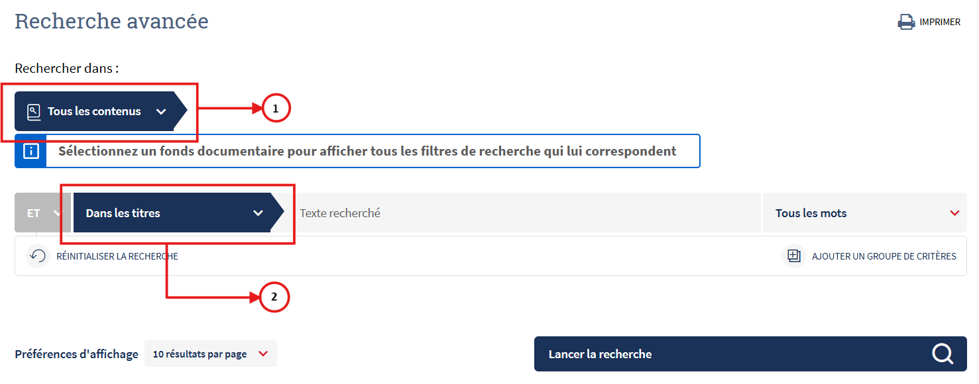

We filtered the result by selecting the type of content in (1). This field only limits 1 type of content. We filtered the required type of regulations in “Textes consolidés” (Consolidated texts), “Journal official” (Official Journal), “Circulaires et instructions” (Circulars and instructions), and “Jurisprudence constitutionnelle” (Constitutional Jurisprudence). Then “Dans les titres” (In the titles) as the next criteria labeled as (2). Below is a sample under “Textes consolidés”.

The search was conducted using keywords from the criteria document.

In the results page, basic metadata (such as the *original title*, *type of regulation*, *date of adoption* and the *source link*) is visible.

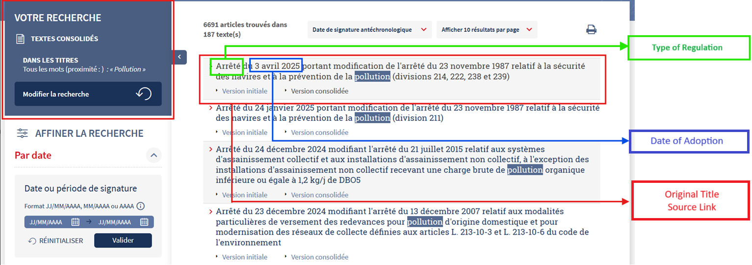However, we determined the *entry into force date* by accessing the specific legislation page. This date is typically the publication date in the Journal Officiel, which can be found in the header (e.g., 'JORF n°... of [date]'). If no specific clause delays enforcement, the publication date is considered the entry into force date by default.

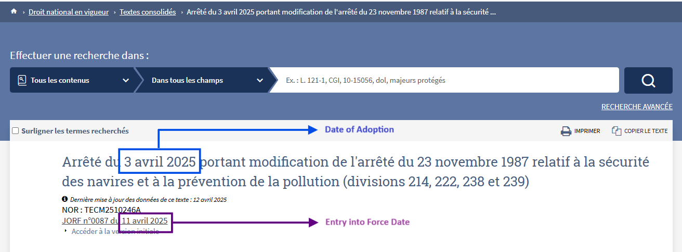

In cases under “Textes consolidés” where the publication date is not readily visible, we need to click "*Accéder à la version initiale”* (Access the initial version) to be redirected to the legislation's page in the *Journal Officiel*, where the publication date is clearly displayed.

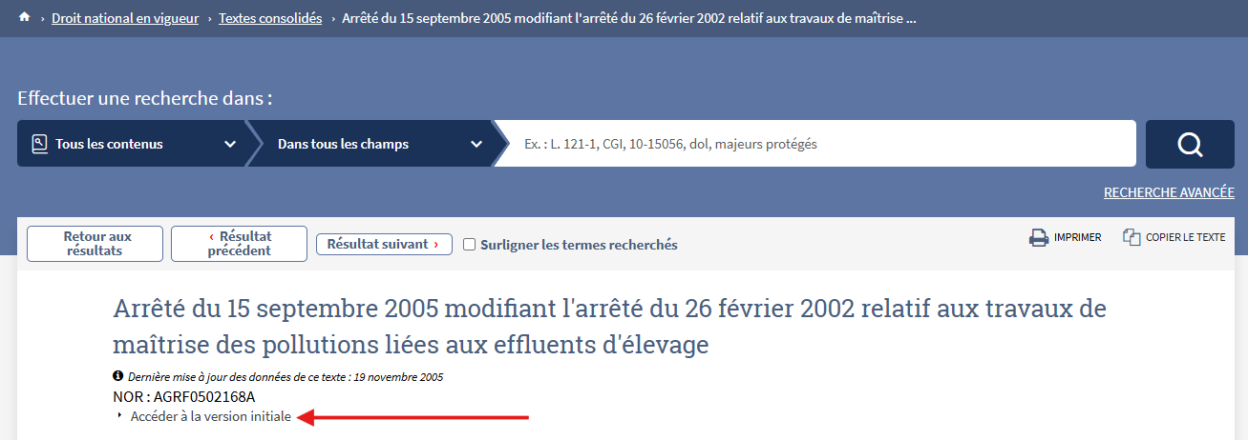

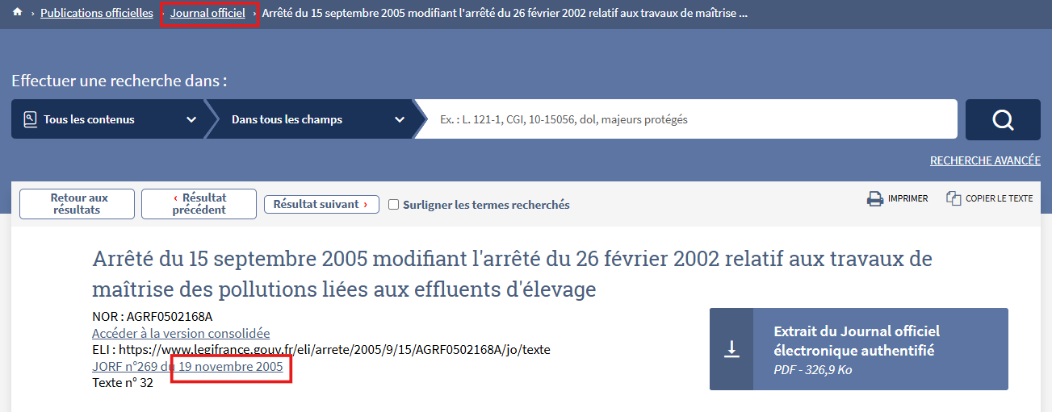

The results are sorted in chronological order, with the most recent entry appearing first. The search will primarily target the following types of regulation: Laws (Lois), Decrees (Décrets), Orders (Arrêtés), and Circulars (Circulaires).

In the search field, we entered keywords found in the title or within the content, whichever returns more relevant results.